

**CONTAINERS AND DOCKERS**

**Submitted by:**

**NAME: Tanishqua Tellakula**

**SAP ID: 500084269**

**Roll number :R120220007**

**Batch: B1(Hons)**

**EXPERIMENT 2**

**AIM: Working with Docker (Basic Commands)**

**Steps to Complete:**

1. ***Search a Redis image on DockerHub***

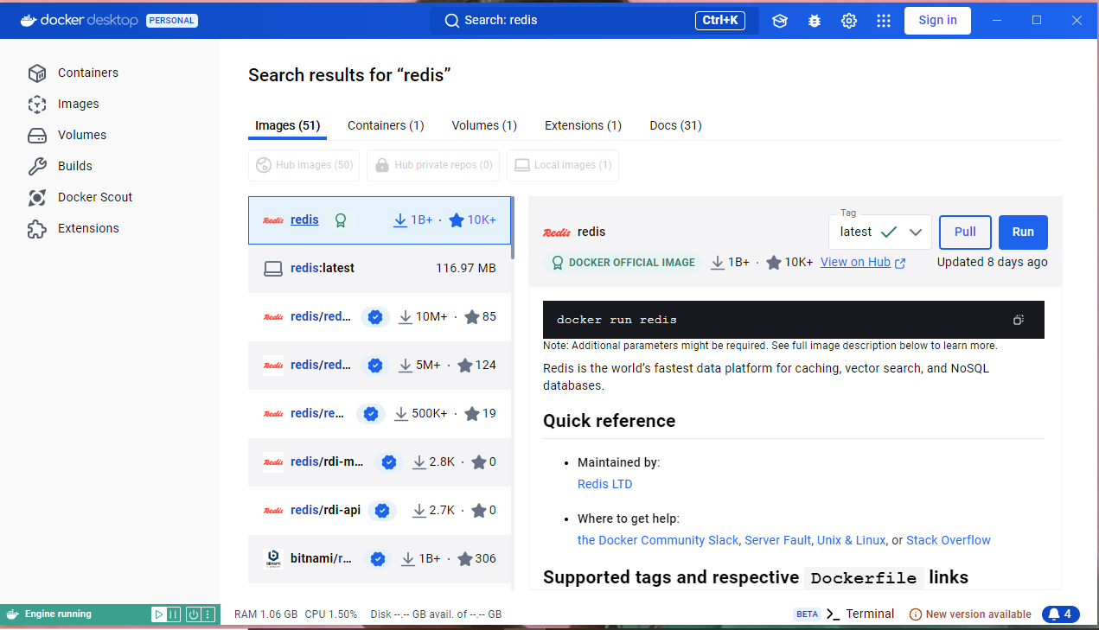

1. **Run Docker Container of Redis Image in background**

* *Pulling redis image on local machine to use it offline*

*Docker pull redis*

* *This command will pull the redis image from dockers file*

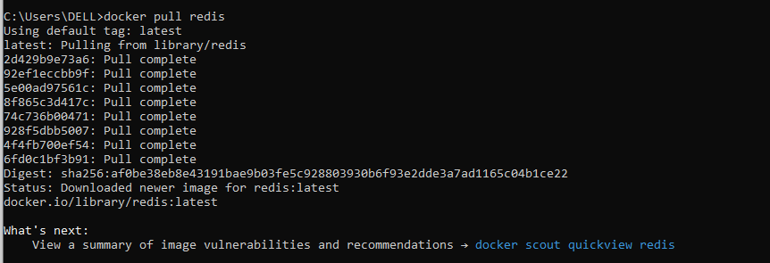

***For* Run Docker Container of Redis Image in background**

*Command -docker run -d -name*

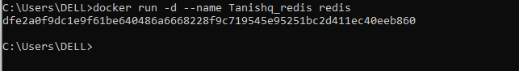

1. ***Run Docker PS and Docker PS –a***

* *Use of docker ps is provide a list of docker container on the machine . docker ps show only running containers by default.*
* *To view all the containers -a flag is used with docker ps*

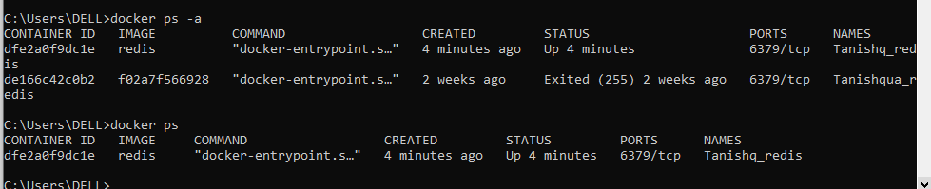

1. ***Run Docker Container and take its console***

* *To view running docker containers -use docker ps*
* *To take its console i.e. enter inside container use docker exec -it<container_name/ID> /bin/bash*

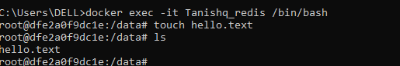

* *To exit the console use command -exit*



1. ***Create a Docker Volume and connect it***

* *To create volume use -docker volume create <volume_name>*

